𝗧𝗵𝗲 𝗘𝘃𝗼𝗹𝘂𝘁𝗶𝗼𝗻 𝗼𝗳 𝗮 𝗗𝗮𝘁𝗮 𝗘𝗻𝗴𝗶𝗻𝗲𝗲𝗿: 𝗙𝗿𝗼𝗺 𝗦𝗤𝗟 𝘁𝗼 𝗦𝗰𝗮𝗹𝗮𝗯𝗹𝗲 𝗗𝗮𝘁𝗮 𝗣𝗹𝗮𝘁𝗳𝗼𝗿𝗺𝘀
The funniest career journey you'll ever see... and surprisingly, it's accurate. 😄
Many people think Data Engineering is all about writing SQL queries or building ETL pipelines.
In reality, a great Data Engineer combines Data Modeling + Distributed Systems + Cloud + Software Engineering + Business Understanding to build reliable, scalable, and AI-ready data platforms.
𝗛𝗲𝗿𝗲 𝗮𝗿𝗲 𝟭𝟬 𝗹𝗲𝘀𝘀𝗼𝗻𝘀 𝗲𝘃𝗲𝗿𝘆 𝗮𝘀𝗽𝗶𝗿𝗶𝗻𝗴 𝗗𝗮𝘁𝗮 𝗘𝗻𝗴𝗶𝗻𝗲𝗲𝗿 𝘀𝗵𝗼𝘂𝗹𝗱 𝗿𝗲𝗺𝗲𝗺𝗯𝗲𝗿:
𝟏. 𝐒𝐐𝐋 𝐢𝐬 𝐭𝐡𝐞 𝐟𝐨𝐮𝐧𝐝𝐚𝐭𝐢𝐨𝐧 – Master joins, window functions, query optimization, and data manipulation before moving to advanced tools.
𝟐. 𝐃𝐚𝐭𝐚 𝐦𝐨𝐝𝐞𝐥𝐢𝐧𝐠 𝐦𝐚𝐭𝐭𝐞𝐫𝐬 – Well-designed schemas make analytics faster, pipelines simpler, and systems easier to maintain.
𝟑. 𝐄𝐓𝐋/𝐄𝐋𝐓 𝐢𝐬 𝐦𝐨𝐫𝐞 𝐭𝐡𝐚𝐧 𝐦𝐨𝐯𝐢𝐧𝐠 𝐝𝐚𝐭𝐚 – Build pipelines that are reliable, reusable, and resilient to failures.
𝟒. 𝐂𝐥𝐨𝐮𝐝 𝐢𝐬 𝐭𝐡𝐞 𝐧𝐞𝐰 𝐬𝐭𝐚𝐧𝐝𝐚𝐫𝐝 – Understanding platforms like Azure, AWS, or GCP is essential for modern data engineering.
𝟓. 𝐃𝐚𝐭𝐚 𝐪𝐮𝐚𝐥𝐢𝐭𝐲 𝐢𝐬 𝐧𝐨𝐧-𝐧𝐞𝐠𝐨𝐭𝐢𝐚𝐛𝐥𝐞 – Bad data leads to bad decisions. Validation, testing, and monitoring are just as important as ingestion.
𝟔. 𝐏𝐞𝐫𝐟𝐨𝐫𝐦𝐚𝐧𝐜𝐞 𝐨𝐩𝐭𝐢𝐦𝐢𝐳𝐚𝐭𝐢𝐨𝐧 𝐢𝐬 𝐚 𝐬𝐮𝐩𝐞𝐫𝐩𝐨𝐰𝐞𝐫 – Partitioning, indexing, clustering, caching, and efficient storage formats can save both time and cost.
𝟕. 𝐀𝐮𝐭𝐨𝐦𝐚𝐭𝐢𝐨𝐧 𝐬𝐜𝐚𝐥𝐞𝐬 𝐞𝐯𝐞𝐫𝐲𝐭𝐡𝐢𝐧𝐠 – Orchestration, CI/CD, Infrastructure as Code, and automated testing make data platforms production-ready.
𝟖. 𝐎𝐛𝐬𝐞𝐫𝐯𝐚𝐛𝐢𝐥𝐢𝐭𝐲 𝐢𝐬 𝐚 𝐦𝐮𝐬𝐭 – Monitor pipeline health, data freshness, lineage, and failures before users discover them.
𝟗. 𝐀𝐈 𝐢𝐬 𝐜𝐡𝐚𝐧𝐠𝐢𝐧𝐠 𝐭𝐡𝐞 𝐫𝐨𝐥𝐞 – Today's Data Engineers are building RAG pipelines, vector databases, real-time architectures, and AI-ready data platforms.
𝟏𝟎. 𝐍𝐞𝐯𝐞𝐫 𝐬𝐭𝐨𝐩 𝐥𝐞𝐚𝐫𝐧𝐢𝐧𝐠 – The ecosystem evolves rapidly. Spark, Snowflake, Databricks, Iceberg, Kafka, AI Agents, and new cloud services continue to redefine the role.
💡 𝗧𝗵𝗲 𝗯𝗶𝗴𝗴𝗲𝘀𝘁 𝘁𝗮𝗸𝗲𝗮𝘄𝗮𝘆?
A Data Engineer isn't created by mastering a single tool.
It's the combination of SQL, Data Modeling, Distributed Computing, Cloud Platforms, Software Engineering, Data Quality, and Continuous Learning that enables engineers to build scalable systems powering Analytics, AI, and Machine Learning.
📌𝗙𝗼𝗿 𝗠𝗲𝗻𝘁𝗼𝗿𝘀𝗵𝗶𝗽/ 𝟭:𝟭 𝗖𝗮𝗹𝗹 𝗯𝗼𝗼𝗸 𝗵𝗲𝗿𝗲 -- https://lnkd.in/gjHqeHMq
📌 𝐋𝐨𝐨𝐤𝐢𝐧𝐠 𝐟𝐨𝐫 𝐑𝐞𝐬𝐮𝐦𝐞 𝐡𝐚𝐯𝐢𝐧𝐠 𝟗𝟎+ 𝐀𝐓𝐒 𝐬𝐜𝐨𝐫𝐞? 𝗗𝗼𝘄𝗻𝗹𝗼𝗮𝗱 𝗥𝗲𝗰𝗿𝘂𝗶𝘁𝗲𝗿-𝗔𝗽𝗽𝗿𝗼𝘃𝗲𝗱 𝗥𝗲𝘀𝘂𝗺𝗲 𝗧𝗲𝗺𝗽𝗹𝗮𝘁𝗲 -https://lnkd.in/gREWXtSr
Activate to view larger image,
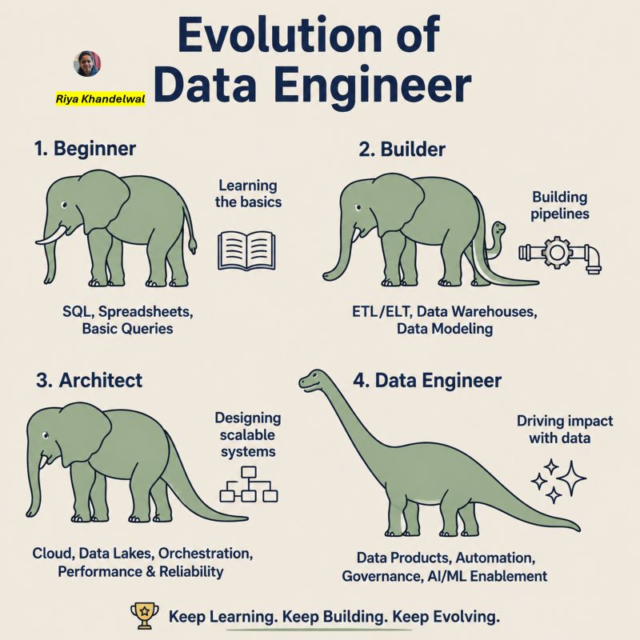

Most data engineers don't plateau because they lack technical skills.
They plateau because they don't understand what their next level actually demands.
This "data engineering ladder" makes one thing clear:
Every level is a different game.
𝐉𝐮𝐧𝐢𝐨𝐫 𝐃𝐚𝐭𝐚 𝐄𝐧𝐠𝐢𝐧𝐞𝐞𝐫 (𝐅𝐨𝐮𝐧𝐝𝐚𝐭𝐢𝐨𝐧 𝐒𝐭𝐚𝐠𝐞)
→ Write SQL queries and basic Python scripts
→ Build simple ETL pipelines with guidance
→ Learn tools: Airflow, dbt, Spark, cloud storage
→ Understand data types, schemas, and basic modelling
Your job: Make data move, not art
𝐌𝐢𝐝-𝐋𝐞𝐯𝐞𝐥 𝐃𝐚𝐭𝐚 𝐄𝐧𝐠𝐢𝐧𝐞𝐞𝐫 (𝐆𝐫𝐨𝐰𝐭𝐡 𝐒𝐭𝐚𝐠𝐞)
→ Build and own end-to-end pipelines independently
→ Add data quality checks, tests, and monitoring
→ Optimise for cost, performance, and schedule reliability
→ Collaborate with analysts and scientists on data needs
Your job: Move from delivery to dependability
𝐒𝐞𝐧𝐢𝐨𝐫 𝐃𝐚𝐭𝐚 𝐄𝐧𝐠𝐢𝐧𝐞𝐞𝐫 (𝐈𝐦𝐩𝐚𝐜𝐭 𝐒𝐭𝐚𝐠𝐞)
→ Design robust, reusable data platform components
→ Define ingestion, transformation, and serving patterns
→ Debug production incidents and prevent future ones
→ Mentor juniors and set team coding standards
Your job: Create systems, not just pipelines
𝐒𝐭𝐚𝐟𝐟 𝐃𝐚𝐭𝐚 𝐄𝐧𝐠𝐢𝐧𝐞𝐞𝐫 (𝐋𝐞𝐚𝐝𝐞𝐫𝐬𝐡𝐢𝐩 𝐒𝐭𝐚𝐠𝐞)
→ Lead org-wide data infrastructure initiatives
→ Introduce data contracts and ownership frameworks
→ Reduce duplication and inconsistency across domains
→ Influence tooling decisions without holding authority
Your job: Drive standards, not just solutions
𝐏𝐫𝐢𝐧𝐜𝐢𝐩𝐚𝐥 𝐃𝐚𝐭𝐚 𝐄𝐧𝐠𝐢𝐧𝐞𝐞𝐫 (𝐕𝐢𝐬𝐢𝐨𝐧 𝐒𝐭𝐚𝐠𝐞)
→ Define long-term data architecture and strategy
→ Establish the organisation's single source of truth
→ Mentor senior engineers across teams
→ Connect data infrastructure decisions to business outcomes
Your job: Think in platforms, not pipelines
𝐃𝐚𝐭𝐚 𝐀𝐫𝐜𝐡𝐢𝐭𝐞𝐜𝐭 (𝐈𝐧𝐧𝐨𝐯𝐚𝐭𝐢𝐨𝐧 𝐒𝐭𝐚𝐠𝐞)
→ Design enterprise-wide data ecosystems
→ Evaluate emerging technologies: lakehouses, streaming, AI-ready infra
→ Solve data trust and governance at scale
→ Represent data engineering at the executive level
Your job: Connect data strategy with long-term business value
Most data engineers try to grow by learning more tools.
The real shift happens when you start solving different problems.
𝐒𝐨 𝐚𝐬𝐤 𝐲𝐨𝐮𝐫𝐬𝐞𝐥𝐟:
Are you preparing for your next role… or just getting better at your current one?
♻️ Repost if this helps someone on your team see their next step.
Follow for more on data engineering careers.
Looking for a mentor in Data Engineering, do schedule a Discovery call here - https://tally.so/r/mOOvpY
Activate to view larger image,
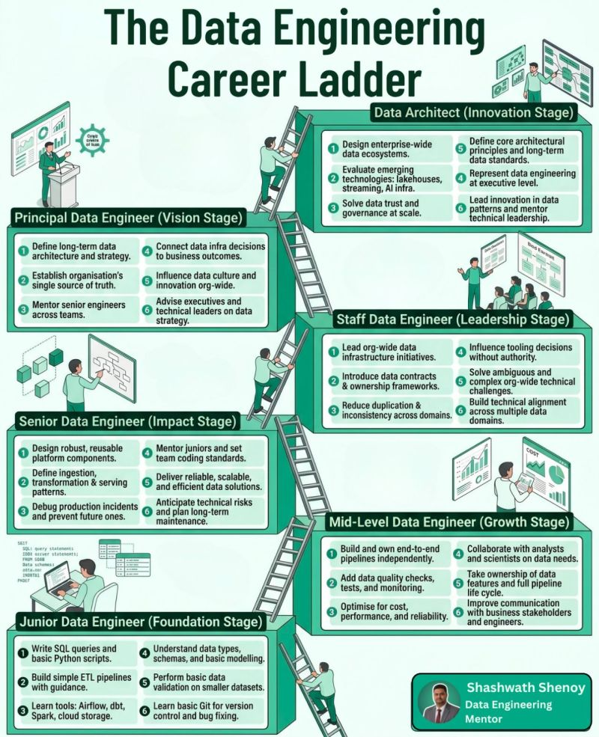

𝗗𝗮𝘁𝗮 𝗘𝗻𝗴𝗶𝗻𝗲𝗲𝗿𝘀 𝗶𝗻 𝟮𝟬𝟮𝟳 𝘄𝗼𝗻’𝘁 𝗷𝘂𝘀𝘁 𝗯𝘂𝗶𝗹𝗱 𝗽𝗶𝗽𝗲𝗹𝗶𝗻𝗲𝘀.
𝗧𝗵𝗲𝘆’𝗹𝗹 𝗯𝘂𝗶𝗹𝗱 𝗶𝗻𝘁𝗲𝗹𝗹𝗶𝗴𝗲𝗻𝘁 𝗱𝗮𝘁𝗮 𝘀𝘆𝘀𝘁𝗲𝗺𝘀.
The role of a 𝗗𝗮𝘁𝗮 𝗘𝗻𝗴𝗶𝗻𝗲𝗲𝗿 is evolving faster than ever.
A few years ago, success meant:
✅ Building ETL pipelines
✅ Writing SQL transformations
✅ Moving data from A → B
✅ Scheduling workflows
✅ Fixing broken jobs at 2 AM 😅
But the next generation of Data Engineers?
The expectation is shifting from 𝗽𝗶𝗽𝗲𝗹𝗶𝗻𝗲 𝗯𝘂𝗶𝗹𝗱𝗲𝗿𝘀 → 𝗽𝗹𝗮𝘁𝗳𝗼𝗿𝗺 𝘁𝗵𝗶𝗻𝗸𝗲𝗿𝘀.
Here’s what I believe will define the 𝟮𝟬𝟮𝟳 𝗗𝗮𝘁𝗮 𝗘𝗻𝗴𝗶𝗻𝗲𝗲𝗿:
🔹 𝗔𝗜-𝗘𝗻𝗵𝗮𝗻𝗰𝗲𝗱 𝗣𝗶𝗽𝗲𝗹𝗶𝗻𝗲𝘀
Engineers won’t just write pipelines — they’ll design systems that optimize, monitor, and even generate workflows using AI.
🔹 𝗗𝗮𝘁𝗮 𝗣𝗿𝗼𝗱𝘂𝗰𝘁𝘀 & 𝗗𝗮𝘁𝗮 𝗠𝗲𝘀𝗵 𝗧𝗵𝗶𝗻𝗸𝗶𝗻𝗴
The focus will shift from datasets to business-ready data products with ownership and trust built in.
🔹 𝗢𝗿𝗰𝗵𝗲𝘀𝘁𝗿𝗮𝘁𝗶𝗼𝗻 𝗮𝘁 𝗦𝗰𝗮𝗹𝗲
Beyond cron jobs — event-driven, intelligent, real-time orchestration will become the norm.
🔹 𝗗𝗮𝘁𝗮 𝗤𝘂𝗮𝗹𝗶𝘁𝘆 𝗯𝘆 𝗗𝗲𝘀𝗶𝗴𝗻
Observability, lineage, governance, and quality checks will no longer be “nice to have.”
They’ll be mandatory.
🔹 𝗢𝘂𝘁𝗰𝗼𝗺𝗲-𝗗𝗿𝗶𝘃𝗲𝗻 𝗘𝗻𝗴𝗶𝗻𝗲𝗲𝗿𝗶𝗻𝗴
The question will no longer be:
❌ “Did the pipeline run?”
It will become:
✅ “Did this data create measurable business impact?”
One thing is becoming very clear:
The future Data Engineer will need to think less like a developer of pipelines and more like an architect of intelligent data ecosystems.
And no — SQL isn’t disappearing.
But 𝗦𝗤𝗟 + 𝗔𝗜 + 𝗦𝘆𝘀𝘁𝗲𝗺 𝗗𝗲𝘀𝗶𝗴𝗻 + 𝗚𝗼𝘃𝗲𝗿𝗻𝗮𝗻𝗰𝗲 + 𝗗𝗼𝗺𝗮𝗶𝗻 𝗧𝗵𝗶𝗻𝗸𝗶𝗻𝗴 will become the real differentiator.
Codebasics Sabyasachi Bhattacharjee Shashank Singh 🇮🇳 Hemanand Vadivel Rishabh Mishra Thodupunuri Bharath Munna Das Arpita Ghosh Srinath Ankolla NAVEEN S Singaram Harish Kumar Maven Analytics Alex FrebergLuke Barousse Avery Smith Zach Wilson Benjamin Rogojan Aman Kharwal Krish Naik Sundas Khalid Ankit Bansal Pavan Lalwani Dhaval Patel Shakra Shamim Sumit Mittal Esther Anagu, MBA Thoufiq Mohammed
hashtag#DataAnalytics hashtag#DataAnalyst hashtag#CareerGrowth hashtag#SQL hashtag#Excel hashtag#PowerBI hashtag#Python hashtag#Tableau hashtag#BusinessIntelligence hashtag#DataScience hashtag#Analytics hashtag#FreshersJobs hashtag#DataJobs hashtag#Big4 hashtag#MNC hashtag#IT hashtag#TechCareers hashtag#DataCommunity hashtag#Database hashtag#SQLQueries hashtag#DBMS hashtag#LearnSQL
Activate to view larger image,
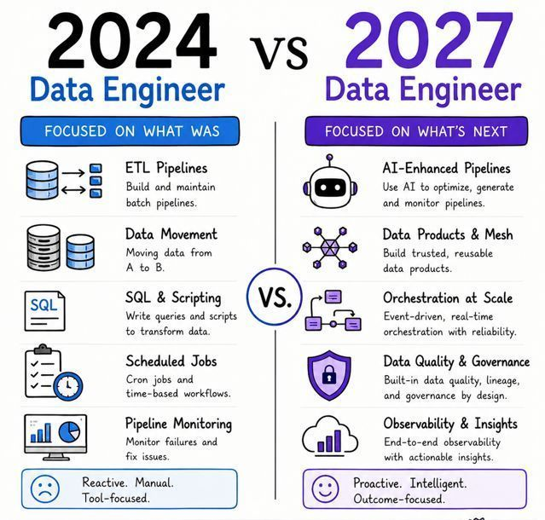

Data engineering is becoming AI-native.
Modern data teams are no longer working only with pipelines, warehouses, and SQL.
They are also using LLMs, vector search, AI agents, automated testing, and intelligent orchestration to build faster and more reliable systems.
Here is the Data Engineer’s AI Toolkit:
𝗟𝗟𝗠𝘀
Use GPT, Claude, Gemini, Llama, Mistral, Cohere, Ollama, and vLLM for coding, documentation, analysis, and local inference.
𝗗𝗮𝘁𝗮 𝗜𝗻𝗴𝗲𝘀𝘁𝗶𝗼𝗻 𝗮𝗻𝗱 𝗖𝗗𝗖
Move batch and streaming data using Airbyte, Fivetran, Debezium, Kafka Connect, dlt, Meltano, and StreamSets.
𝗗𝗮𝘁𝗮 𝗧𝗿𝗮𝗻𝘀𝗳𝗼𝗿𝗺𝗮𝘁𝗶𝗼𝗻
Build clean data models with dbt, SQLMesh, Spark, Databricks, Dataform, Matillion, and Informatica.
𝗪𝗼𝗿𝗸𝗳𝗹𝗼𝘄 𝗢𝗿𝗰𝗵𝗲𝘀𝘁𝗿𝗮𝘁𝗶𝗼𝗻
Coordinate dependencies, retries, and schedules with Airflow, Prefect, Dagster, Kestra, Temporal, and Argo Workflows.
𝗪𝗮𝗿𝗲𝗵𝗼𝘂𝘀𝗲𝘀 𝗮𝗻𝗱 𝗟𝗮𝗸𝗲𝗵𝗼𝘂𝘀𝗲𝘀
Store and process enterprise data using Snowflake, BigQuery, Redshift, Databricks, ClickHouse, Iceberg, and Delta Lake.
𝗤𝘂𝗮𝗹𝗶𝘁𝘆 𝗮𝗻𝗱 𝗢𝗯𝘀𝗲𝗿𝘃𝗮𝗯𝗶𝗹𝗶𝘁𝘆
Validate, monitor, and trace pipelines with Great Expectations, Soda, Deequ, Monte Carlo, OpenLineage, Grafana, and Datadog.
𝗩𝗲𝗰𝘁𝗼𝗿 𝗦𝗲𝗮𝗿𝗰𝗵
Support RAG and semantic retrieval with Pinecone, Weaviate, Qdrant, Milvus, pgvector, Elasticsearch, and Redis.
𝗦𝗲𝗰𝘂𝗿𝗶𝘁𝘆 𝗮𝗻𝗱 𝗚𝗼𝘃𝗲𝗿𝗻𝗮𝗻𝗰𝗲
Control access, privacy, policies, and lineage with Purview, Collibra, Ranger, OPA, Immuta, and Presidio.
𝗔𝗜 𝗔𝗴𝗲𝗻𝘁𝘀 𝗮𝗻𝗱 𝗔𝘂𝘁𝗼𝗺𝗮𝘁𝗶𝗼𝗻
Build intelligent workflows using LangGraph, OpenAI Agents SDK, AutoGen, Semantic Kernel, n8n, CrewAI, and MCP.
The simple way to remember it:
Ingest.
Transform.
Store.
Monitor.
Search.
Govern.
Automate.
The modern data engineer connects reliable data infrastructure with AI-powered workflows, not just pipelines.
Which category is missing from your current toolkit?
Follow Sumit for more such insights!!
Activate to view larger image,


